**Assignment 1**

public class Student {

    private String Sname;

    private String Cname;

    private int StudentID;

    public Student(int id, String sname, String cname) {

        this.StudentID = id;

        this.Sname = sname;

        this.Cname = cname;

    }

    public void display(){

        System.out.println("Student ID: " + this.StudentID);

        System.out.println("Student Name: " + this.Sname);

        System.out.println("Course Name: " + this.Cname);

    }

    public static void main(String args[]){

        Student student = new Student(101, "John Doe", "DYPTC");

        System.out.println("Successful!");

        student.display();

    }

}

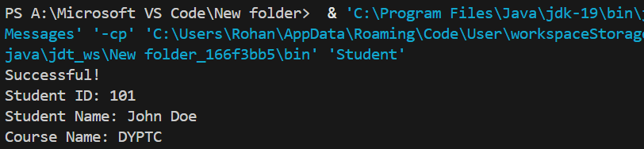**OUTPUT:**

**Assignment 2**

**Before:**

public class Employee{

    int id;

    int age;

    String name;

    boolean isPermanent;

    public Employee(int id, int age, String name, boolean isPermanent) {

        this.id = id;

        this.age = age;

        this.name = name;

        this.isPermanent = isPermanent;

    }

    public void display() {

        System.out.println("ID: " + id + ", Age: " + age + ", Name: " + name + ", Permanent: " + isPermanent);

    }

    public static void main(String[] args) {

        int id=1;

        String name="John Doe";

        boolean isPermanent=true;

        int age=30.5; // compilation error will be occurred.

        Employee emp = new Employee(id, age, name, isPermanent);

        System.out.println("Successfully Started!");

        emp.display();

    }

}

**OUTPUT:**



**AFTER :**

public class Employee{

    protected int id;

    protected int age;

    protected String name;

    protected boolean isPermanent;

    public Employee(int id, int age, String name, boolean isPermanent) {

        this.id = id;

        this.age = age;

        this.name = name;

        this.isPermanent = isPermanent;

    }

    public void display() {

        System.out.println("ID: " + id + ", Age: " + age + ", Name: " + name + ", Permanent: " + isPermanent);

    }

    public static void main(String[] args) {

        int id=1;

        String name="John Doe";

        boolean isPermanent=true;

        int age=(int) 30.5; //compilation error is resolved using narrowing type conversion

        Employee emp = new Employee(id, age, name, isPermanent);

        System.out.println("Successfully Started!");

        emp.display();

    }

}

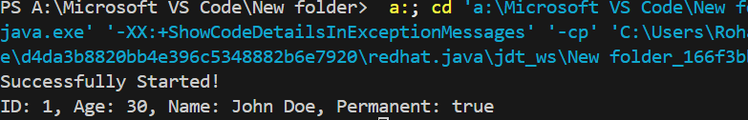**OUTPUT:**

**Assignment 3**

package com.anudip.learning;

public class Person {

    String name="John Doe";

    int age=30;

    int salary=50000;

    public static void main(String[] args) {

        Person person = new Person();

        System.out.println("Test Successful!");

        System.out.println("Name: " + person.name);

        System.out.println("Age: " + person.age);

        System.out.println("Salary: " + person.salary);

    }

}

**OUTPUT:**

